Name: Sandesh Varma                                                                   Date: 21/07/2025

Roll No: CH.EN.U4CSE22078

Experiment No: 2

Aim: To implement eliminate left recursion and left factoring from the given grammar using C program.

1. **Left factoring**

# **Algorithm:**

* Start the processes by getting the grammar and assigning it to the appropriate variables
* Find the common terminal and non-terminal elements and assign them in a separate grammar
* Display the new and modified grammar**.**

Code:

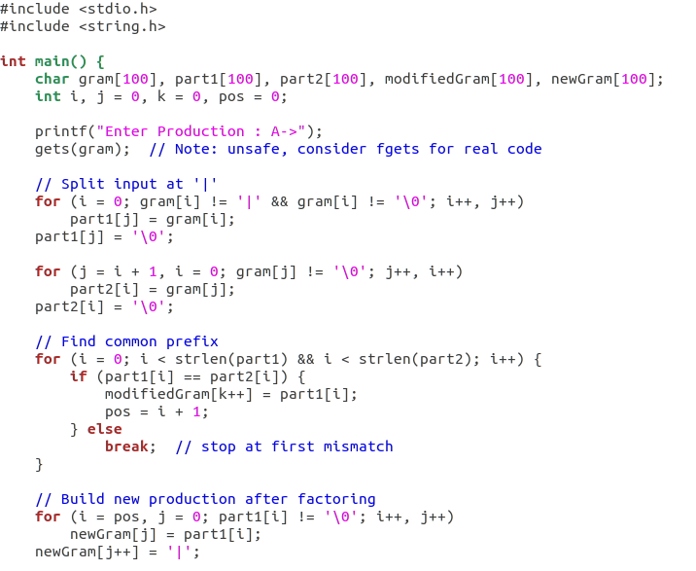

Sandesh Varma

CH.EN.U4CSE22078

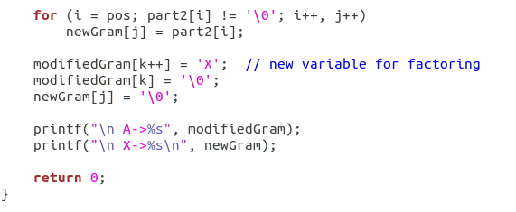

Output:

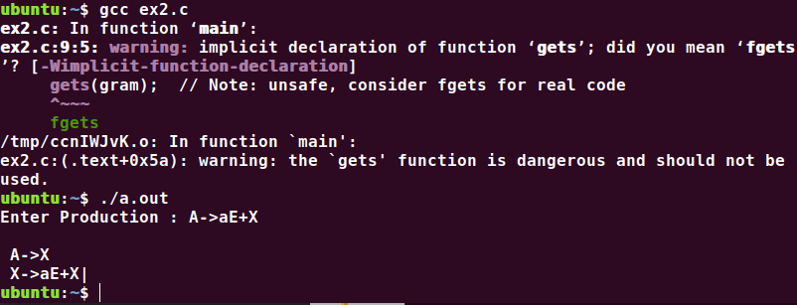

Sandesh Varma

CH.EN.U4CSE22078

1. **Left Recursion**

# **Algorithm:**

1. Start the processes by getting the grammar and assigning it to the appropriate variables.
2. Check if the given grammar has left recursion.
3. Identify the alpha and beta elements in the production.
4. Print the output according to the formula to remove left recursion

Code:

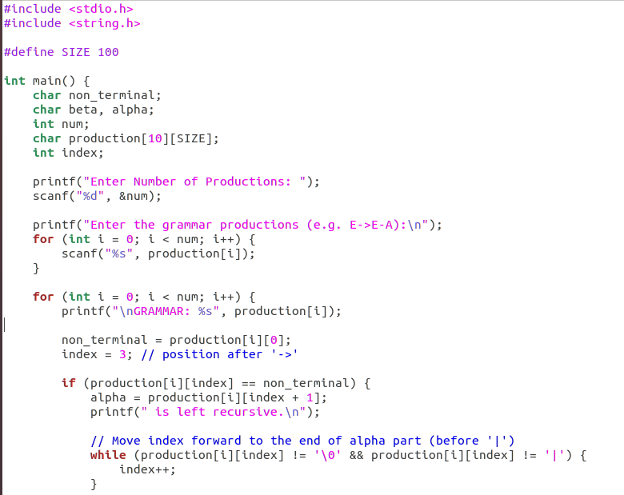

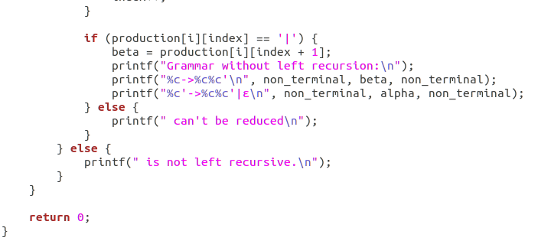

Output:

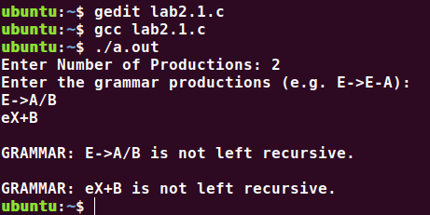

Results: The program to implement left factoring and left recursion has been successfully executed.